PREDICTING MEDICAL INSURANCE CLAIM DENIALS
Rhianna Ruggiero
Bellevue University
DSC 630
11/22/2025

Introduction
A common problem experienced at hospitals and private practices is insurance claim denials. From 2018 to 2024, insurance claim denials for essential medications like insulin rose 16% (Steinzor & Grossi, 2025). These denials cause delays and added stress to both patients and providers and take away from caring for the patient directly (Steinzor & Grossi, 2025). This can affect the patient-provider relationship, delay the patient receiving important necessary medications like insulin and can be frustrating for all (Steinzor & Grossi, 2025). These insurance claim denials can be caused by various factors including incorrect codes for the service or procedure performed, lack of essential supporting documentation, untimely insurance filings or even missing or incomplete patient or provider information on the claim (Ranked, 2023). I would like to help prevent claims from occurring as often by creating a model that can help predict whether a claim will get denied before it is sent to the insurance company.
This project would be useful to hospitals and private practices to ensure that they get their reimbursements on time and that they can treat their patients. I would try and sell this model to the doctors and billing staff and would show how this information can help them to improve their billing procedures at the practice. This would also be useful for CDI teams in hospitals whose jobs are to make sure that the codes are input correctly and that the hospital gets the correct reimbursements for the treatment that they gave to the patients. This model could also even be tweaked to help insurance companies since they wouldn’t have to have people resubmit claims. For this project, I found data based on medical billing scenarios from Kaggle at this link. This data can be useful for solving the problem in that it tells us who the client is, the date of the service, how long it has been since the date of service and insurance details which can all have an impact on whether a claim gets denied. There is also information on why a claim was denied and next steps that should be taken to make sure that the claim gets accepted. All of this information can be used to create a predictive model on insurance claim denials.
For this project, I plan to try out either a decision tree model or random forest model since I am looking for a binary response of either “yes the claim might be denied” or “no it will not”. Random forest models and decision trees are both good for binary classification problems, and I will see which model will give me the highest accuracy. I plan to evaluate the results of these models by looking at the models’ accuracy between testing and training data and seeing how many claims were correctly predicted as being denied. Accuracy may not always be the best indicator of a well performing model however, so other metrics like F1 score or recall can help paint a better picture on how well a model would perform on unseen data. Recall will show how many claims were accurately predicted as being denied out of all of the claims that were actually denied. F1 score can also help in that it combines precision and recall of a model into one metric (Frank, 2018). The score will be a number between 0 and 1 and a number closer to 1 means that the model has a high precision and recall, however it could also be an indication of overfitting (Frank, 2018).
One ethical concern with this proposal is keeping sensitive patient health information safe and to remain compliant with HIPAA laws. It is important to be aware of how the health data is being stored and shared and that it does not break any laws. Another ethical concern with this proposal could be if hospitals and practices use a model like this to pre-screen patients to see if their insurance claims may get denied before giving them treatment and using the results to determine if they will accept a patient or not. Legally, hospitals are not allowed to deny treatment for patients that have an emergency medical condition and must stabilize them regardless of their ability to pay for the treatment (Patino & Ferreira, 2021). Every year around 4%-5% of hospitals in the US are found to have violated the law in this regard, so it would be extra important to ensure that this model is used in an ethical way to help make treatment of patients a smoother process only (Patino & Ferreira, 2021).
With this project, I hope to learn more about creating well-performing models and how to adjust them to perform better. I hope to also learn more about which metrics are the best for determining how well my model will perform. My goal is to eventually work with data in a medical setting, so I would also like to learn a bit more about Revenue Cycle Management at hospitals and to get familiar with the type of data that they use to analyze medical billing and insurance claim issues.
If my original project plan does not work out, I will try to adjust my problem statement in a way that it will work with the data that I have or I will find new data sets that can help to answer my question. The new data set might have to be simpler or longer in order to create a model successfully or may even need to be on a different topic related to healthcare. If I begin to run out of time, I may choose to only test one data model rather than both random forest and a decision tree model. I may also need to adjust my timeline and when I will be completing each step of the project.
Overview of Data Used
Will I be able to answer the questions I want to answer with the data I have?
After exploring my data more thoroughly, I discovered that there could be a problem with the current question I want to answer—can I predict whether a claim will be denied based on other information about the patient, insurance company, treatment provided etc. The data set that I have only contained information on claims that were denied. In order to truly create a model that predicts denials, I would need to have claims that are accepted (or paid) along with ones that are denied so that the model can learn the difference between them.
Do I need to adjust the data and/or driving questions?
Instead of changing the question that I had right away, I decided to look for more data that could help me answer my question. I found a new data set on Kaggle at the following link. This new data set contains information on claims that were denied, paid and ones that are in progress along with other information including patient insurance information, diagnosis codes and procedure codes. Having both denied and paid claims allows me to continue working towards my goal of creating a model to predict claim denials.
Do I need to adjust my model/evaluation choices?
With this new data set I am still able to use the same models that I originally wanted to which include random forest and decision trees. First, I will see how accurate I can get the decision tree model to be and will then try a random forest model if I need to. I believe that decision trees will be good for this scenario in that they are easy to understand and translate so that hospital workers or other users of this model will be able to interpret it easily and make proper adjustments to make sure that their claims do not get denied. I also will be able to evaluate the models the same as mentioned before, using F1 score and recall to be able to see how many claims were accurately predicted to be denied.
What visualizations are especially useful for explaining my data?
Some visualizations that I think will be helpful include bar charts to see how many claims are paid vs how many are denied. It is important to make sure that there isn’t a class imbalance so that the model isn’t biased. I also think that creating a stacked bar chart to show how many claims were paid or denied based on insurance will also be helpful. This should show whether some insurances have more denials than others. Another helpful visualization would be to use a boxplot to see how the billed amount varies for both paid and denied claims. The box plot will be able to show if there are any outliers in the data or if denied claims have a higher billed amount on average compared to paid claims. The box plot will also show how much the data varies for each claim.
Are my original expectations still reasonable?
After exploring the data more and finding the new data set, I believe that my original expectations are still reasonable. I think that a decision tree model will be able to find patterns to determine whether a claim will be denied or paid. I will have to make some changes to the data to ensure that it is ready for modeling including removing any columns that contain data after a claim was denied. For example, the reason code explains why a claim was denied which could be helpful in understanding why claims get denied however this is discovered after the fact and won’t be needed for the model. Once the data is cleaned and prepared I will begin creating the model.
Methods of Analysis
Explain your process for prepping the data
For the data set that I ended up using for this project, I first looked at the rows and the data types of the various columns. I changed data types, checked for any null values and made sure that the new data set contained information on both paid and denied claims. I also made sure that there wasn’t an imbalance of the claim types that would have an adverse effect on the model later.
After cleaning the data a little, I created some visualizations in order to see if I can understand more about the current state of the data. I looked at the distribution of patient income to see if the income was spread out or more concentrated. I also checked the number of each claim status (paid, denied or in process) depending on the claim type (inpatient, outpatient, emergency, routine). This visualization showed that emergency claims had more denials and that there were more approved routine claims than any other type of claim.
After visualizing some of the data, I started to prepare it for modeling. I removed columns that did not add any value for modeling including all of the ID columns. I also decided to remove the date column since I did not have an end date listed and was not sure how much it would help. I filtered the data set so that I would only see approved or denied claims since I am not interested in claims that are only in progress. I then determined which columns were categorical and created dummy variables for those columns.
Build and evaluate at least one model
The first model that I decided to try was a decision tree model. I split the data into testing and training data, with testing data being 20% of the data set and used a depth of 5. I calculated the accuracy of the model which ended up being 67%, which was not great. I decided to see if changing the depth of the tree could help improve accuracy. A depth of 10 ended up decreasing the accuracy to 61% and a depth of 7 led to accuracy of 65% which was still less than my original tree. This analysis led me to believe that some features within the data are not good predictors of claim denials.
I then decided to use a random forest model to see if the accuracy might improve. With 300 estimators, the accuracy of the random forest model ended up being 64% which is lower than the decision tree. Random forest models are ensemble models that can help reduce overfitting, so I wonder if my decision tree model was slightly overfit causing the higher accuracy. I decided to continue to use random forest and see if I could create some feature engineering that would help improve accuracy.
When I started looking at my data set with the dummy variables, I realized that I had over 9000 columns in the data set which could have been making it difficult for the model to make accurate predictions. I checked the number of unique variables in each column, and discovered that the patient income, diagnosis code, procedure code, claim amount and provider location columns contained a lot of unique values. I had expected the code columns to have less codes, but instead it seems that every line contained a different value. It makes sense that the claim amount and patient income columns would have different numbers since people make different amounts of money and claim amount can be affected by many different variables. These are also numeric columns that were not converted to dummy variables. I was also surprised to see that there were so many different locations and originally assumed that the data would be from only a few different places. After discovering this information, I dropped the code columns and the location column since they did not provide enough value for the model. The data set with the dummy variables had a significantly smaller number of columns after making these changes to the data set.
I decided to re-try my decision tree model to see if the accuracy would change after dropping the extra columns, but it remained at 67%. I also decided to try the random forest model again with the extra columns removed and accuracy decreased to 62%. Accuracy is not always the best metric to determine how well your model is working since you may be looking for different things depending on the question you are trying to answer. For example, I am looking to try and limit the number of claims that get denied, which means that I want to catch as many potentially problematic claims as possible before they are submitted. This means that accuracy might not be the best metric to use and that a confusion matrix could help understand what is happening behind the scenes and why accuracy is higher for the decision tree model.
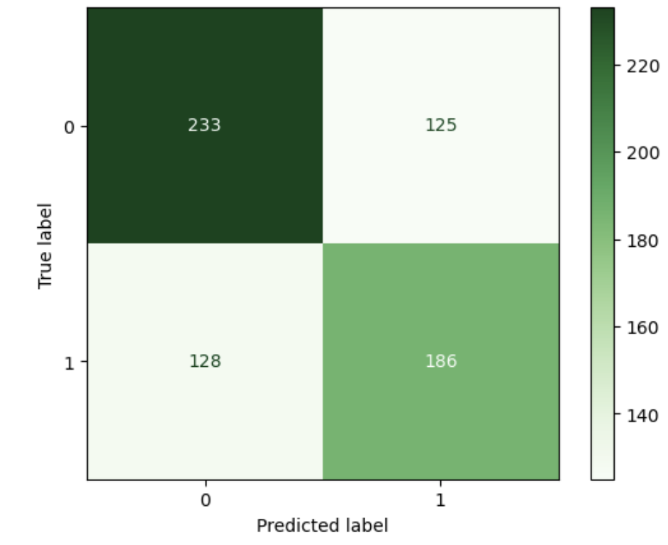
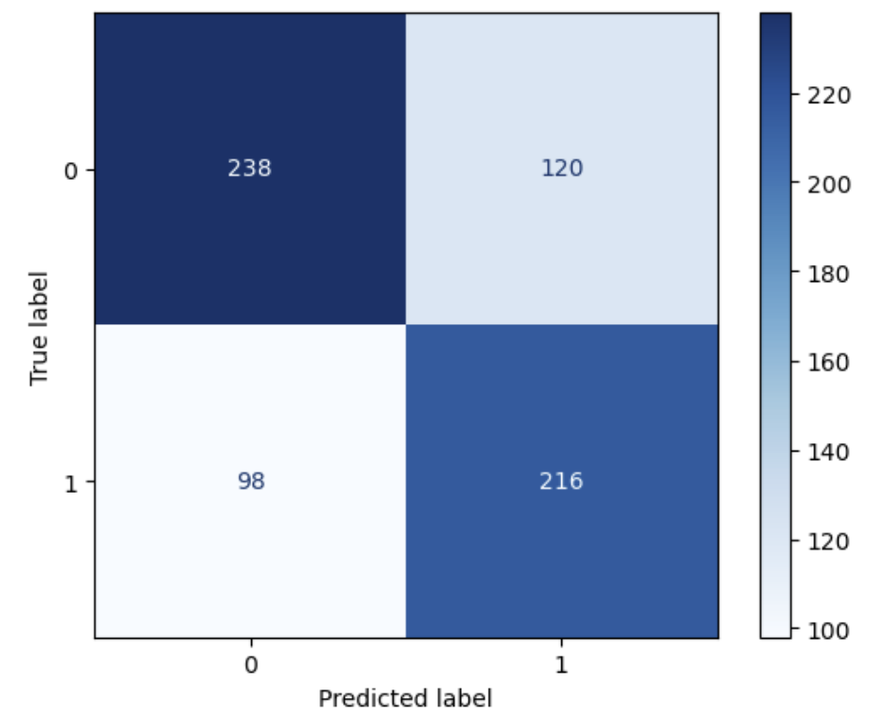
Below, the confusion matrix for the decision tree model is in blue and the confusion matrix for the random forest model is in green. Both models accurately predicted a similar number of denied claims that were actually denied and both predicted a similar number of claims to be approved that were actually denied, which I am trying to limit.
If I had only used accuracy as my metric, I wouldn’t have noticed that both models were actually predicting similar numbers for the claims that are actually denied.
After analyzing the confusion matrices, I started utilizing feature creation to try and improve my models’ results. I created some extra features including a column that compared claim amount to a patient’s income, a column that grouped ages together and a column that concatenated claim type and provider specialty together. I created a new data frame with new dummy variables and re-made the confusion matrices to see how they changed and also calculated the F1 score, precision and recall of both models to compare.
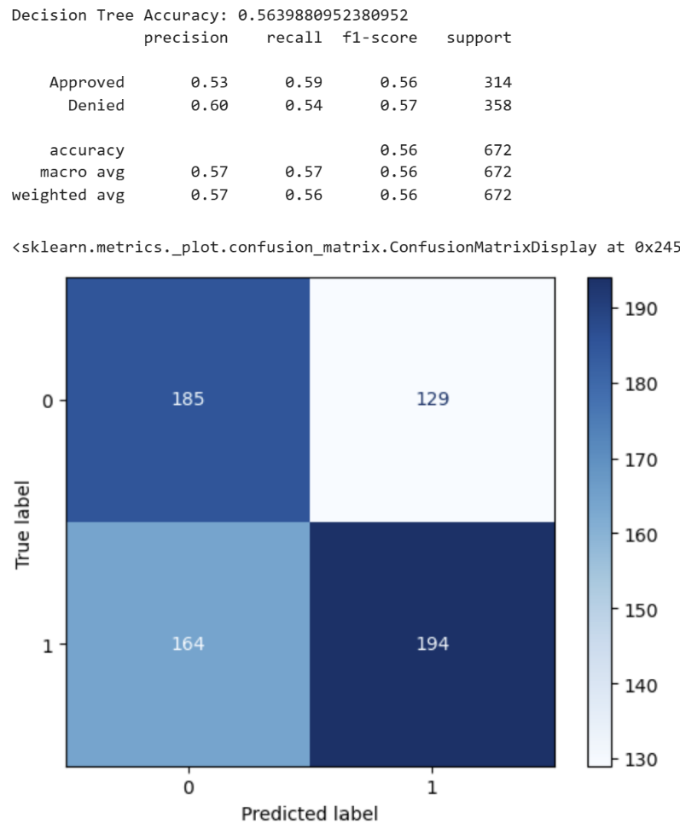
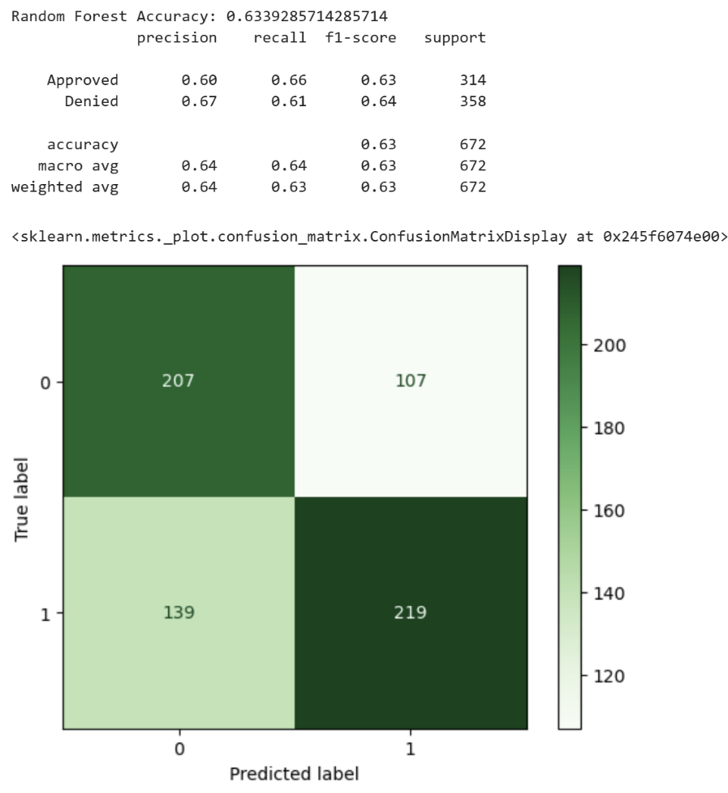
After creating new features, the random forest model accuracy actually increased and the decision tree model accuracy decreased. The confusion matrices show that the random forest model was better at predicting actually denied claims as denied and actually approved claims as approved. The decision tree model also predicted more approved claims as denied, and more denied claims as being approved which is not what I am looking for. This leads me to believe more that the decision tree model might have been overfit since new features decreased accuracy and led to the decision to just use the random forest model from now on.
Now that I decided on a random forest model, I tried to tune the model so that I could catch as many denied claims as possible. I tried changing the class weight to make denied claims more important however this ended up making the accuracy and prediction of denied claims worse, so I decided to keep the class weight balanced. Next I tried to lower the threshold for predicting denied claims to 0.4 rather than 0.5 to see how that would affect the model. Changing the threshold would make it so that if the model is 40% confident that the claim is denied, it will label it as denied (instead of being 50% confident). Once I made this change, the model was able to accurately predict almost 300 claims to be denied. Changing the threshold also means that the number of approved claims that are inaccurately being labeled as denied would increase as well however, and this number increased to almost 200. Only 71 denied claims were labeled as approved after making this change which is better than it was before.
I still wanted to see if I could improve the results even more, and decided to create an ROC curve and to use GridSearchCV to tune the hyperparameters.
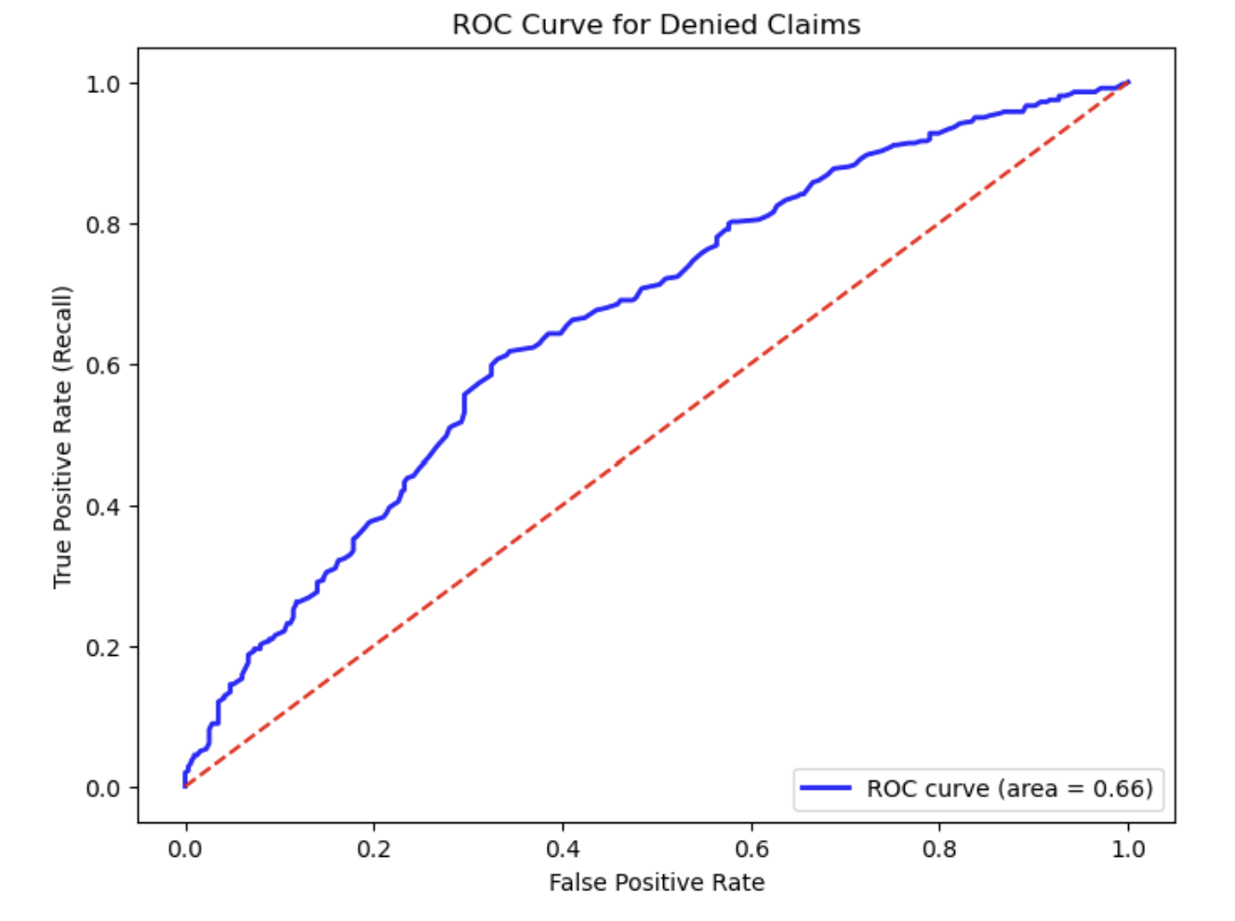
The ROC curve for my model had an area of 0.66 under the curve which means that my model is not great at separating approved and denied claims but it is better than just randomly guessing. It looks like the best threshold is between 0.3 and 0.4, so I tried changing it to 0.375 which led to more approved claims being incorrectly classified as denied. This change would decrease the efficiency of the model, so I decide to stick with 0.4 as my threshold.
Last, I tried using GridSearchCV to tune the model’s parameters. In this scenario, I care more about the recall for denied claims than I do for the approved claims so I made the positive label denied rather than approved. After testing various different numbers of estimators, depths and more, the best parameters ended up being the following:
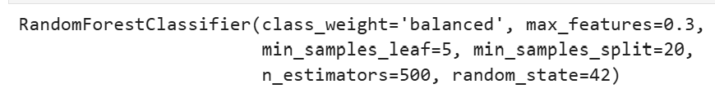
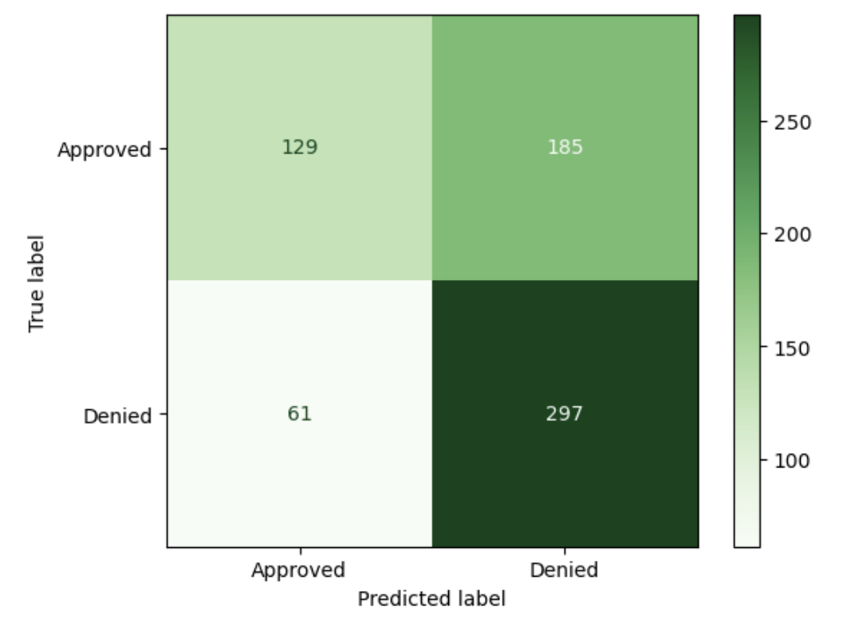
I used these parameters to tune my random forest model and lowered the threshold to 0.4 and ended up with a high denied recall of 0.83 and the following confusion matrix:

This tuned model had the best balanced confusion matrix that I could create. Almost 300 out of around 350 denied claims were accurately predicted, with 61 getting mislabeled as approved when they were actually denied. 129 approved claims were accurately predicted as approved, and 185 approved claims were mislabeled as denied. Although this model inaccurately predicts a high number of denied claims that are actually approved, it catches most of the denied claims and had a high recall along with a higher number of approved claims being accurately labeled as approved.
Results & Findings Explained
Interpret your results
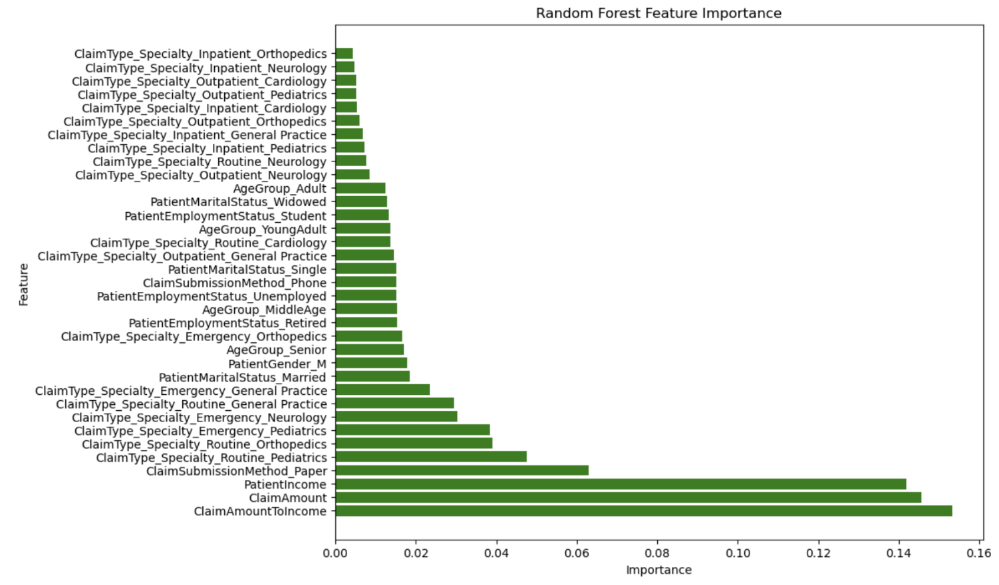
I checked the most important feature of the model and the most influential one ended up being the claim amount to income column that I created. The claim amount and patient income features also had a big influence on the model’s decision making. After these two, the amount of influence that other features have on the model drops significantly. A paper submission method also has some influence, but not as much as the income and claim amount do. The chart below shows the features and their influence on the random forest model’s decision making.
Conclusion
The model did not have the highest accuracy metric at only 63% however it was able to accurately predict denied claims 83% of the time. The recall for the approved class was only 41% though which shows that the model favors the denied class. In this scenario, it is more important to capture as many denied claims as possible since we are trying to fix these claims before they get submitted in order to help patients get their care in a timely manner and for hospitals and private practices to get reimbursed on time.
The features that were most important had to do with financial information including claim amount and a patients income, and a comparison between these two variables. This suggests that these features have the most influence on whether a claim will be denied. The model does have room for improvement in order to increase accuracy more and to increase recall for approved claims in order to not waste time re-checking claims that would get approved however it is better than just double checking every single claim. Adding more features to the dataset, trying other models and cleaning the data more could potentially increase model performance in the future. I would recommend gathering more data to test the model on and to keep evaluating the model and tuning the parameters in order to get the best results and to decrease false positives and false negatives.
I would say that this model is not yet ready for deployment. I think that the model could be tuned even further with more time and can eventually be used by a hospital or private practice.
Analyze the ethical implications of the project
Some ethical implications could be bias towards patients that have certain income levels. Private practices might use the information to determine which patients they decide to see which would be wrong and discriminatory. It is important to ensure that the results of this model would not affect the treatment of the patients and would only be used as a way to determine which medical claims might be at higher risk of getting denied the first time around in order to help patients and improve claim timeliness. The model should also be used as a guideline to help flag claims that may get denied, rather than ones that will definitely be denied. An expert should also evaluate the results and use their experience with claim denials to determine if a claim really may be denied or not and if there are any errors. The model should also be updated over time in order to adjust it if there are new policies or if a new metric appears that has an influence on a claim’s likeliness to be denied. As always, patient health care data should be secured and access only by authorized users and must remain in compliance with HIPAA laws.
What did you learn?
I learned a lot while completing this project about searching for data, cleaning data and how to tune models. I also learned a lot about how to make sure that the model is accurate and that sometimes accuracy is not the best metric for a model depending on the question you are trying to answer. Not all data will have trends that can be easily found and can easily be turned into a data model and sometimes you have to dig to find patterns using feature engineering. I also learned how long it can take to make a model that can be used in production and how much work goes into tuning them as well.
References
Frank, E. L. (2018, October 18). Understanding the F1 score. Medium. https://ellielfrank.medium.com/understanding-the-f1-score-55371416fbe1
hpaulj. (2018, April 11). How to set threshold to scikit-learn random forest model [Answer]. Stack Overflow. https://stackoverflow.com/questions/49785904/how-to-set-threshold-to-scikit-learn-random-forest-model
Patino, C. M., & Ferreira, J. C. (2021). Recall bias. In StatPearls [Internet]. StatPearls Publishing. https://www.ncbi.nlm.nih.gov/books/NBK557812/
Ranked, C. (2023, December 4). Common reasons for insurance claims denials. EnableComp. https://enablecomp.com/denial-prevention-and-resolution/reasons-for-denial/#:~:text=Incorrect%20or%20duplicate%20claims%2C%20lack,also%20likely%20to%20be%20denied.
Steinzor, P., & Grossi, G. (2025, February 27). How insurance claim denials harm patients’ health, finances. AJMC. https://www.ajmc.com/view/how-insurance-claim-denials-harm-patients-health-finances

